**Table 1. Baseline patient and tumour characteristics by centre.**

|  |  |  |  |  |  |
| --- | --- | --- | --- | --- | --- |
|  | **Total (N=4071)** | **Amsterdam (N=983)** | **Berlin (N=1343)** | **Rotterdam (N=566)** | **Warsaw (N=1179)** |
| **Positive SN status** | 889 (21.8%) | 236 (24.0%) | 259 (19.3%) | 170 (30.0%) | 224 (19.0%) |
| **Males** | 1996 (49.0%) | 497 (50.6%) | 753 (56.1%) | 273 (48.2%) | 473 (40.1%) |
| **Age** |  |  |  |  |  |
| Median (Q1, Q3) | 55.0 (43.0, 66.0) | 55.0 (43.0, 65.0) | 62.0 (48.0, 71.0) | 52.0 (40.0, 62.0) | 51.0 (42.0, 62.0) |
| Min - Max | 13.0 - 94.0 | 15.0 - 89.0 | 13.0 - 94.0 | 13.0 - 88.0 | 15.0 - 83.0 |
| **Ulceration** | 1171 (29.8%) | 265 (27.8%) | 263 (20.0%) | 166 (33.3%) | 477 (40.9%) |
| Missing | 141 | 30 | 31 | 68 | 12 |
| **Location** |  |  |  |  |  |
| Arm | 615 (15.6%) | 128 (13.5%) | 217 (16.2%) | 86 (15.2%) | 184 (17.0%) |
| Leg | 1189 (30.2%) | 277 (29.2%) | 324 (24.2%) | 218 (38.5%) | 370 (34.3%) |
| Trunk | 1815 (46.1%) | 407 (42.8%) | 654 (48.9%) | 242 (42.8%) | 512 (47.4%) |
| Head and neck | 314 (8.0%) | 138 (14.5%) | 142 (10.6%) | 20 (3.5%) | 14 (1.3%) |
| Missing | 138 | 33 | 6 | 0 | 99 |
| **Histology** |  |  |  |  |  |
| SSM | 2164 (58.2%) | 598 (62.6%) | 910 (70.0%) | 285 (55.9%) | 371 (39.0%) |
| NM | 1226 (33.0%) | 276 (28.9%) | 290 (22.3%) | 195 (38.2%) | 465 (48.8%) |
| ALM | 126 (3.4%) | 29 (3.0%) | 54 (4.2%) | 16 (3.1%) | 27 (2.8%) |
| Other | 202 (5.4%) | 14 (2.7%) | 46 (3.5%) | 89 (9.3%) | 53 (5.5%) |
| Missing | 353 | 27 | 43 | 56 | 227 |
| **Breslow** |  |  |  |  |  |
| Mean (SD) | 2.8 (3.3) | 2.6 (2.0) | 2.3 (2.5) | 2.8 (2.3) | 3.6 (4.9) |
| Min - Max | 0.1 - 90.0 | 0.5 - 22.0 | 0.1 - 30.0 | 0.3 - 20.0 | 0.1 - 90.0 |
| Missing | 59 | 9 | 16 | 6 | 28 |
| **Multiple fields** | 374 (9.2%) | 223 (22.7%) | 41 (3.1%) | 87 (15.4%) | 23 (2.0%) |
| **Total number of negative SN** |  |  |  |  |  |
| Mean (SD) | 1.7 (1.4) | 2.2 (1.6) | 1.6 (1.3) | 1.6 (1.4) | 1.2 (1.0) |
| Min - Max | 0.0 - 15.0 | 0.0 - 15.0 | 0.0 - 13.0 | 0.0 - 10.0 | 0.0 - 9.0 |
| Missing | 162 | 0 | 27 | 1 | 134 |
| **Total number of positive SN** |  |  |  |  |  |
| Mean (SD) | 0.3 (0.6) | 0.3 (0.6) | 0.2 (0.4) | 0.4 (0.7) | 0.3 (0.6) |
| Min - Max | 0.0 - 5.0 | 0.0 - 4.0 | 0.0 - 2.0 | 0.0 - 4.0 | 0.0 - 5.0 |
| Missing | 1 | 0 | 1 | 0 | 0 |
| **SN tumour burden** |  |  |  |  |  |
| Mean (SD) | 1.2 (1.3) | 1.1 (0.8) | 1.0 (0.5) | 1.1 (1.3) | 1.4 (2.0) |
| Min - Max | 0.0 - 38.0 | 0.0 - 8.0 | 0.0 - 8.0 | 0.0 - 15.0 | 0.0 - 38.0 |
| Missing | 301 | 120 | 163 | 18 | 0 |
| **Location metastasis in lymph** |  |  |  |  |  |
| Subcap | 3319 (88.1%) | 793 (92.1%) | 1123 (95.2%) | 440 (80.3%) | 963 (81.7%) |
| Combined | 213 (5.7%) | 39 (4.5%) | 27 (2.3%) | 43 (7.8%) | 104 (8.8%) |
| Parenchymal | 86 (2.3%) | 5 (0.6%) | 11 (0.9%) | 19 (3.5%) | 51 (4.3%) |
| Multifocal | 45 (1.2%) | 6 (0.7%) | 9 (0.8%) | 21 (3.8%) | 9 (0.8%) |
| Extensive | 105 (2.8%) | 18 (2.1%) | 10 (0.8%) | 25 (4.6%) | 52 (4.4%) |
| Missing | 303 | 122 | 163 | 18 | 0 |
| **Recurrence** | 862 (21.2%) | 208 (21.2%) | 175 (13.0%) | 160 (28.3%) | 319 (27.1%) |
| **Deaths** | 606 (14.9%) | 127 (12.9%) | 148 (11.0%) | 115 (20.3%) | 216 (18.3%) |
| **Melanoma specific mortality** | 504 (12.4%) | 98 (10.0%) | 101 (7.5%) | 102 (18.0%) | 203 (17.2%) |

Abbreviations: Q1, first quantile (Q1); Q3, third quantile; SD, standard deviation; SN, sentinel node, SSM, superficial spreading melanoma; NM, nodular melanoma; ALM, acral lentiginous melanoma; LMM, lentigo maligna melanoma.

**Table 2. Hazard ratios of full model predicting 5-year recurrence**. This Table displays the hazard ratios together with the 95 percent confidence intervals of the full Cox proportional hazards model predicting 5-year recurrence.

|  |  |  |  |  |  |  |
| --- | --- | --- | --- | --- | --- | --- |
|  | **Negative SN** | | **Positive SN** | | $$χ^{2}$$ | |
|  | **HR** | **CI** | **HR** | **CI** | **Main** | **Interactions** |
| **Positive SN status** |  |  | 1.363 | [0.192; 9.653] |  | 38.1 |
| **Male** | 1.234 | [1.020; 1.491] | 0.995 | [0.614; 1.613] | 4.7 | 2.1 |
| **Age** | 1.155 | [0.854; 1.561] | 1.583 | [0.736; 3.406] | 7.4 | 1.8 |
| **Ulceration** | 1.808 | [1.473; 2.219] | 1.357 | [0.815; 2.259] | 37.4 | 3.4 |
| **Location** |  |  |  |  |  |  |
| Arm | (ref) |  | (ref) |  |  |  |
| Leg | 1.386 | [1.030; 1.866] | 1.047 | [0.434; 2.523] | 22.4 | 1.8 |
| Trunk | 1.498 | [1.118; 2.005] | 1.047 | [0.442; 2.480] |  |  |
| Head and neck | 2.318 | [1.588; 3.384] | 1.492 | [0.506; 4.401] |  |  |
| **Histology** |  |  |  |  |  |  |
| SSM | (ref) |  | (ref) |  |  |  |
| NM | 1.180 | [0.933; 1.492] | 1.285 | [0.731; 2.259] | 9.5 | 0.5 |
| ALM | 1.610 | [0.984; 2.635] | 1.407 | [0.401; 4.938] |  |  |
| Other | 0.981 | [0.626; 1.539] | 1.054 | [0.255; 4.356] |  |  |
| **Breslow** | 2.132 | [1.854; 2.453] | 1.554 | [1.091; 2.214] | 131.3 | 8.4 |
| **Multiple fields** | 1.300 | [0.946; 1.786] | 1.377 | [0.649; 2.920] | 6.4 | 0.1 |
| **Total number of negative SN** | 0.977 | [0.925; 1.032] |  |  | 0.7 |  |
| **Total number of positive SN** | 0.973 | [0.823; 1.151] |  |  | 0.1 |  |
| **SN tumour burden (Rdamcrit)** | 1.174 | [1.042; 1.322] |  |  | 6.9 |  |
| **Location metastasis in lymph node (Dewar)** |  |  |  |  |  |  |
| Subcap | (ref) |  |  |  |  |  |
| Combined | 1.508 | [1.074; 2.118] |  |  | 9.6 |  |
| Parenchymal | 1.101 | [0.714; 1.697] |  |  |  |  |
| Multifocal | 0.906 | [0.505; 1.627] |  |  |  |  |
| Extensive | 1.206 | [0.729; 1.996] |  |  |  |  |
| *Intercept* | -0.007 | [-0.081; 0.067] |  |  |  |  |
| *Slope* | 0.997 | [0.925; 1.069] |  |  |  |  |
| *C-index* | 0.765 | [0.750; 0.780] |  |  |  |  |
| *C-index recalibrated MSM* | 0.784 | [0.765; 0.803] |  |  |  |  |

C-index is corrected for optimism. Abbreviations: HR, hazard ratio; CI, 95 percent confidence interval; $χ^{2}$, chi-square form anova test; Int., the for interaction terms; SN, sentinel node, SSM, superficial spreading melanoma; NM, nodular melanoma; ALM, acral lentiginous melanoma; LMM, lentigo maligna melanoma; MSM, melanoma specific mortality.

**Table 3. Hazard ratios of final model predicting 5-year recurrence**. This Table displays the hazard ratios together with the 95 percent confidence intervals of the full Cox proportional hazards model predicting 5-year recurrence selected by backward selection with p-values maximum of 0.01.

|  |  |  |  |  |  |  |
| --- | --- | --- | --- | --- | --- | --- |
|  | **Negative SN** | | **Positive SN** | | $$χ^{2}$$ | |
|  | **HR** | **CI** | **HR** | **CI** | **Main** | **Int.** |
| **Positive SN status** |  |  | 3.638 | [2.759; 4.799] | 135.7 |  |
| **Age** | 1.401 | [1.117; 1.757] | 1.401 | [1.117; 1.757] | 8.5 |  |
| **Ulceration** | 1.661 | [1.423; 1.938] | 1.661 | [1.423; 1.938] | 41.5 |  |
| **Location** |  |  |  |  |  |  |
| Arm | (ref) |  | (ref) |  |  |  |
| Leg | 1.271 | [0.991; 1.630] | 1.271 | [0.991; 1.630] | 20.2 |  |
| Trunk | 1.415 | [1.109; 1.805] | 1.415 | [1.109; 1.805] |  |  |
| Head and neck | 1.982 | [1.460; 2.692] | 1.982 | [1.460; 2.692] |  |  |
| **Breslow** | 2.255 | [2.006; 2.536] | 1.534 | [1.131; 2.081] | 203.3 | 16.2 |
| **SN tumour burden (Rdamcrit)** | 1.223 | [1.129; 1.325] | 1.223 | [1.129; 1.325] | 24.1 |  |
| *Intercept* | -0.004 | [-0.078; 0.069] |  |  |  |  |
| *Slope* | 1.001 | [0.928; 1.074] |  |  |  |  |
| *C-index* | 0.762 | [0.746; 0.777] |  |  |  |  |
| *C-index recalibrated MSM* | 0.781 | [0.761; 0.800] |  |  |  |  |

C-index is corrected for optimism. Abbreviations: HR, hazard ratio; CI, 95 percent confidence interval; $χ^{2}$, chi-square form anova test; Int., the for interaction terms; SN, sentinel node, SSM, superficial spreading melanoma; NM, nodular melanoma; ALM, acral lentiginous melanoma; LMM, lentigo maligna melanoma; MSM, melanoma specific mortality.

**Figure 1. Risk distribution and nomogram**.

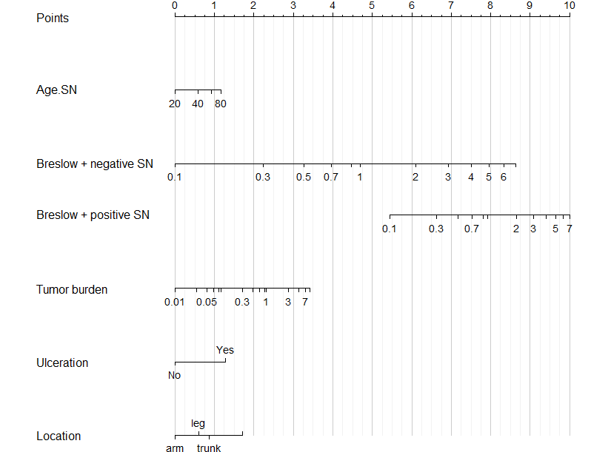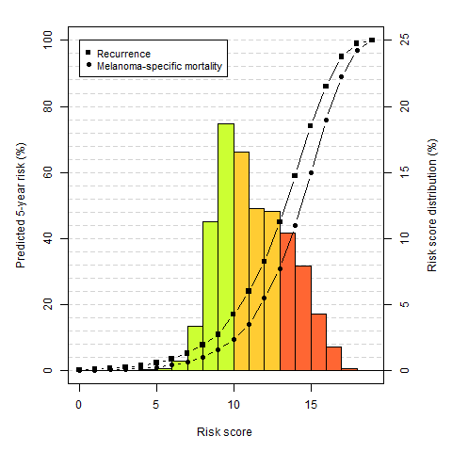

**Figure 1. Calibration curves for final model predicting recurrence and melanoma specific mortality for each centre for patients with positive or negative sentinel nodes.**

|  |  |  |
| --- | --- | --- |
|  | **Recurrence** | **Melanoma specific mortality** |
| **Both positive and negative** |  |  |
| **Only positive** |  |  |
| **Only negative** |  |  |

**SUPPLEMENT**

**Table 2. Hazard ratios of refitted full model predicting 5-year melanoma specific mortality**. This Table displays the hazard ratios together with the 95 percent confidence intervals of the refitted full Cox proportional hazards model predicting 5-year melanoma specific mortality.

|  |  |  |  |  |  |  |
| --- | --- | --- | --- | --- | --- | --- |
|  | **Negative SN** | | **Positive SN** | | $$χ^{2}$$ | |
|  | **HR** | **CI** | **HR** | **CI** | **Main** | **Int.** |
| **Positive SN status** |  |  | 0.348 | [0.027; 4.464] | 33.4 |  |
| **Male** | 1.365 | [1.060; 1.758] | 1.175 | [0.622; 2.219] | 7 | 0.6 |
| **Age** | 0.808 | [0.548; 1.192] | 1.630 | [0.605; 4.393] | 5.4 | 5.2 |
| **Ulceration** | 2.116 | [1.628; 2.751] | 1.594 | [0.824; 3.082] | 40.8 | 2 |
| **Location** |  |  |  |  |  |  |
| Arm | (ref) |  | (ref) |  |  |  |
| Leg | 1.049 | [0.703; 1.565] | 0.879 | [0.284; 2.722] | 17.5 | 5 |
| Trunk | 1.705 | [1.175; 2.472] | 0.953 | [0.326; 2.785] |  |  |
| Head and neck | 1.701 | [0.993; 2.912] | 1.571 | [0.380; 6.489] |  |  |
| **Histology** |  |  |  |  |  |  |
| SSM | (ref) |  | (ref) |  |  |  |
| NM | 1.110 | [0.828; 1.488] | 1.073 | [0.521; 2.212] | 5.8 | 0.5 |
| ALM | 1.616 | [0.810; 3.223] | 1.724 | [0.324; 9.188] |  |  |
| Other | 0.938 | [0.517; 1.702] | 0.569 | [0.068; 4.740] |  |  |
| **Breslow** | 2.319 | [1.942; 2.768] | 1.602 | [1.016; 2.525] | 105.2 | 6.8 |
| **Multiple fields** | 1.055 | [0.688; 1.618] | 1.425 | [0.518; 3.915] | 2.9 | 1.0 |
| **Total number of negative SN** | 0.954 | [0.884; 1.030] |  | 1.4 |  |  |
| **Total number of positive SN** | 0.950 | [0.761; 1.185] |  | 0.2 |  |  |
| **SN tumour burden (Rdamcrit)** | 1.254 | [1.039; 1.513] |  | 5.6 |  |  |
| **Location metastasis in lymph node (Dewar)** |  |  |  |  |  |  |
| Subcap | (ref) |  |  |  |  |  |
| Combined | 1.275 | [0.760; 2.137] |  | 1.5 |  |  |
| Parenchymal | 1.392 | [0.803; 2.415] |  |  |  |  |
| Multifocal | 1.190 | [0.591; 2.399] |  |  |  |  |
| Extensive | 1.318 | [0.578; 3.003] |  |  |  |  |
| *Intercept* | -0.008 | [-0.103; 0.087] |  |  |  |  |
| *Slope* | 0.999 | [0.912; 1.086] |  |  |  |  |
| *C-index* | 0.790 | [0.771; 0.809] |  |  |  |  |

C-index corrected for optimism. Abbreviations: HR, hazard ratio; CI, 95 percent confidence interval; $χ^{2}$, chi-square form anova test; Int., the for interaction terms; SN, sentinel node, SSM, superficial spreading melanoma; NM, nodular melanoma; ALM, acral lentiginous melanoma; LMM, lentigo maligna melanoma.

**Table 3. Hazard ratios of refitted final model predicting 5-year melanoma specific mortality**. This Table displays the hazard ratios together with the 95 percent confidence intervals of the refitted full Cox proportional hazards model predicting 5-year recurrence selected by backward selection with p-values maximum of 0.01.

|  |  |  |  |  |  |  |
| --- | --- | --- | --- | --- | --- | --- |
|  | **Negative** | | **Positive** | | $$χ^{2}$$ | |
|  | **HR** | **CI** | **HR** | **CI** | **Main** | **Int.** |
| **Positive SN status** |  |  | 3.921 | [2.709; 5.675] |  | 89.1 |
| **Age** | 1.389 | [1.164; 1.657] | 1.389 | [1.164; 1.657] | 13.2 |  |
| **Ulceration** | 1.846 | [1.522; 2.239] | 1.846 | [1.522; 2.239] | 38.7 |  |
| **Breslow** | 2.389 | [2.053; 2.779] | 1.579 | [1.063; 2.347] | 142.5 | 11.0 |
| **SN tumour burden (Rdamcrit)** | 1.316 | [1.180; 1.467] | 1.316 | [1.180; 1.467] | 24.3 |  |
| *Intercept* | -0.006 | [-0.100; 0.088] |  |  |  |  |
| *Slope* | 0.999 | [0.910; 1.087] |  |  |  |  |
| *C-index* | 0.782 | [0.763; 0.802] |  |  |  |  |

C-index corrected for optimism. Abbreviations: HR, hazard ratio; CI, 95 percent confidence interval; $χ^{2}$, chi-square form anova test; Int., the for interaction terms; SN, sentinel node, SSM, superficial spreading melanoma; NM, nodular melanoma; ALM, acral lentiginous melanoma; LMM, lentigo maligna melanoma.